I need a time crunch on this circuit / door. What is the time crunch?
Parents coming
Bad guys coming (that would be cool and potentially very interesting)
Grandpa has built a mechanism that locks it all down.
It can only be opened on Fridays
The library book is due tomorrow. That’s kind of funny actually. And charlotte’s dad is coming.

They make their circuit, hold it to the sensor, the door opens, they go inside.
There’s not much drama in the way it’s written right now. Gavin just has the code written and done. Would be more fun if we could show him struggling with it a bit.
And it would be neat if there was a time crunch of some kind. They are at the Fortress, they need to get the door to unlock because parents are coming over soon to pick them up.
So they get inside and have only minutes to spare…they’re looking for another clue they can take home. There is a piece of machinery in there. You need to describe it. Let’s also put the map in there.
We need to get to the underground, the challenges, the stone.
It needs to be exciting when the door opens. What’s exciting on the other side? A piece of a time machine.
A door to the underground that is locked and requires a motor connection that spins precisely one way then another.
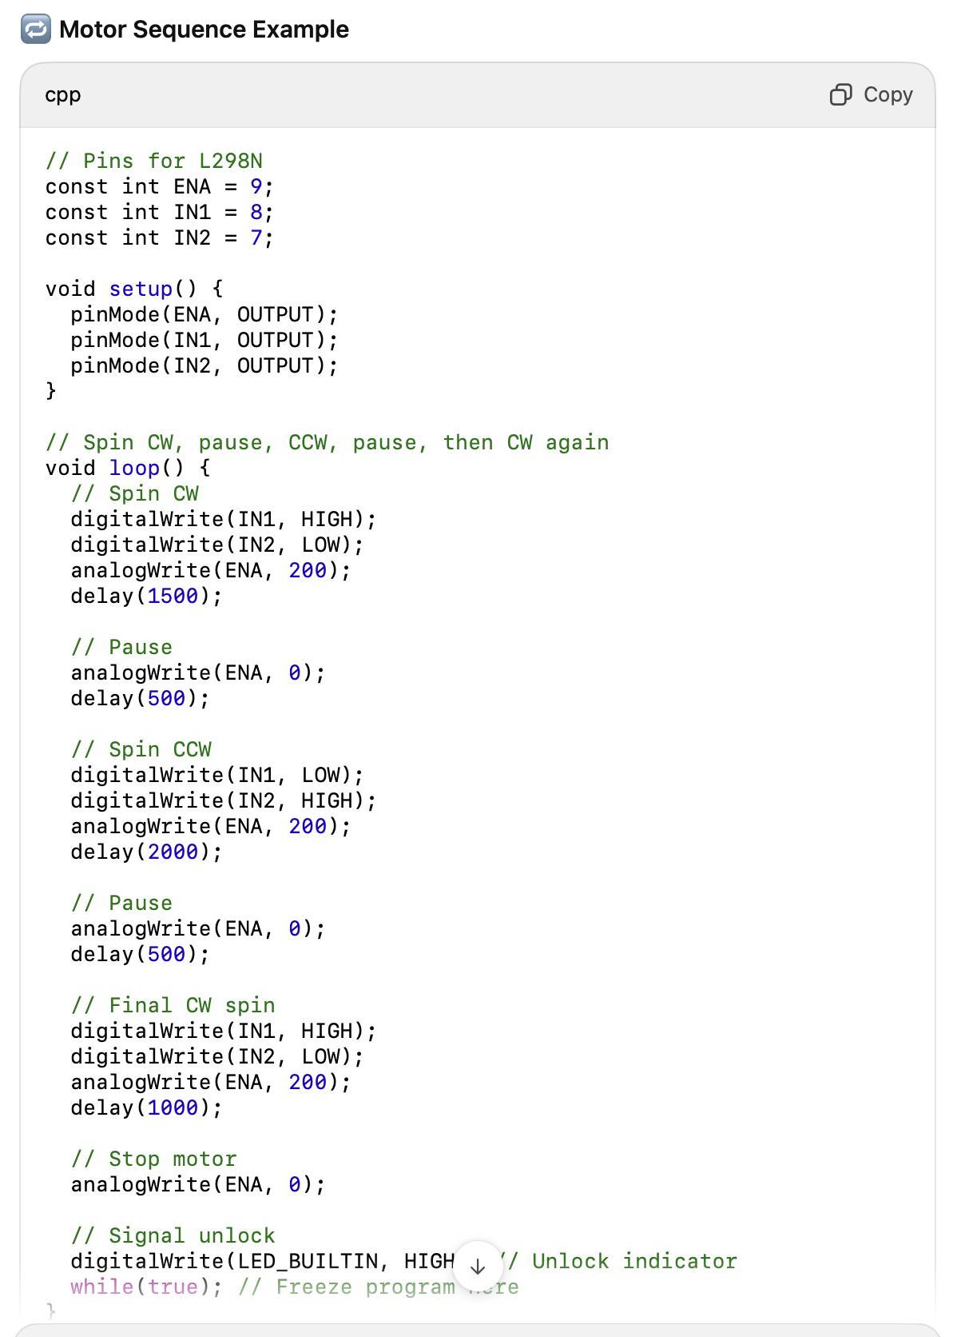

There might also be a Simon says you have to defeat in order to get a new Dewey Decimal number
So this requires you to build a circuit with an L298N.

